Lets say we have six data points {A,B,C,D,E,F}.
- Step- 1: In the initial step, we calculate the proximity of individual points and consider all the six data points as individual clusters as shown in the image below.
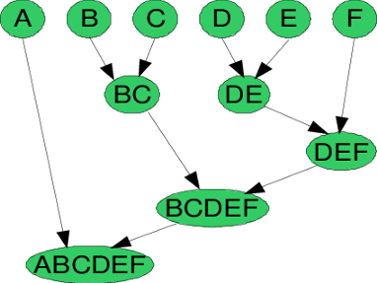

Agglomerative Hierarchical Clustering Technique
- Step- 2: In step two, similar clusters are merged together and formed as a single cluster. Let’s consider B,C, and D,E are similar clusters that are merged in step two. Now, we’re left with four clusters which are A, BC, DE, F.
- Step- 3: We again calculate the proximity of new clusters and merge the similar clusters to form new clusters A, BC, DEF.
- Step- 4: Calculate the proximity of the new clusters. The clusters DEF and BC are similar and merged together to form a new cluster. We’re now left with two clusters A, BCDEF.
- Step- 5: Finally, all the clusters are merged together and form a single cluster.

